**Spring REST using Spring Boot 3**

**EXERCISE 5: REST – Get country based on country code**

**Source Code**

**OBJECTIVE**

Create endpoint:

* URL: /country/{code}
* Method: GET
* Returns: JSON object of country that matches the code (case insensitive)
* Service class handles the logic of searching from XML.

**STEP 1: country.xml — Add a List of Countries**

**xml**

<bean id="countryList" class="java.util.ArrayList">

<constructor-arg>

<list>

<bean class="com.cognizant.springlearn.model.Country">

<property name="code" value="IN"/>

<property name="name" value="India"/>

</bean>

<bean class="com.cognizant.springlearn.model.Country">

<property name="code" value="US"/>

<property name="name" value="United States"/>

</bean>

<bean class="com.cognizant.springlearn.model.Country">

<property name="code" value="CN"/>

<property name="name" value="China"/>

</bean>

</list>

</constructor-arg>

</bean>

**STEP 2: CountryService.java**

**java**

package com.cognizant.springlearn.service;

import com.cognizant.springlearn.model.Country;

import org.springframework.context.ApplicationContext;

import org.springframework.context.support.ClassPathXmlApplicationContext;

import org.springframework.stereotype.Service;

import java.util.List;

@Service

public class CountryService {

public Country getCountry(String code) {

ApplicationContext context = new ClassPathXmlApplicationContext("country.xml");

List<Country> countryList = context.getBean("countryList", List.class);

// Case-insensitive search using stream

return countryList.stream()

.filter(c -> c.getCode().equalsIgnoreCase(code))

.findFirst()

.orElse(null); // You can throw a custom exception instead

}

}

**STEP 3: CountryController.java**

**java**

package com.cognizant.springlearn.controller;

import com.cognizant.springlearn.model.Country;

import com.cognizant.springlearn.service.CountryService;

import org.slf4j.Logger;

import org.slf4j.LoggerFactory;

import org.springframework.beans.factory.annotation.Autowired;

import org.springframework.web.bind.annotation.*;

@RestController

public class CountryController {

private static final Logger LOGGER = LoggerFactory.getLogger(CountryController.class);

@Autowired

private CountryService countryService;

@GetMapping("/country/{code}")

public Country getCountry(@PathVariable String code) {

LOGGER.info("START - getCountry() with code: " + code);

Country country = countryService.getCountry(code);

LOGGER.info("END - getCountry()");

return country;

}

}

**STEP 4: Run and Test**

**Run the Application**

In Eclipse, run your main Spring Boot application class (with @SpringBootApplication)

**Test the Endpoint**

**In Browser or Postman:**

**URL:**

<http://localhost:8083/country/in>

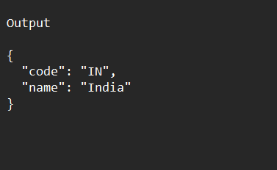

**//country/us, /country/CN — all will work case-insensitively.**